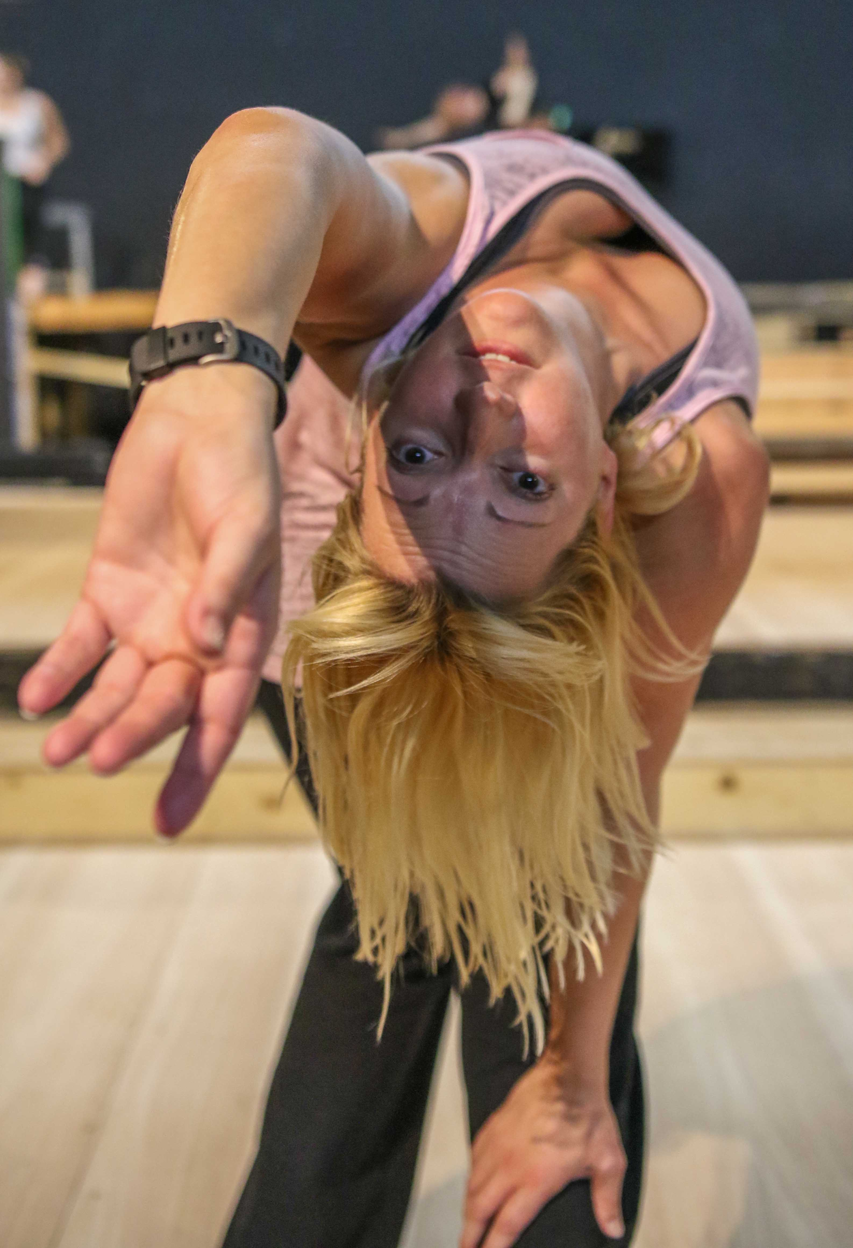

August 18, 2017

Dear Volunteer:

You are part of a very exclusive club. You have been an integral part of a Pentacle Theatre production.

For you actors, do you remember the last time you were rehearsing for a Pentacle production downtown?

Yeah, I do too.

Remember the carpeting? I’ve attached a couple of pictures, just to remind you of what it looks like. Remember how your feet hurt after a while? Yeah, me too. A thin layer of carpet barely masks the concrete underneath.

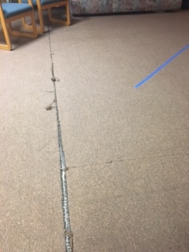
You might agree that it’s time for a major overhaul of our Pentacle rehearsal space. Unfortunately, it’s not the responsibility of the building’s owners to replace worn out carpeting. This is community theater and we—as in you and I—have to do it. It’s not cheap, especially if we want it to be something that’s better quality and more durable, given the action it gets.

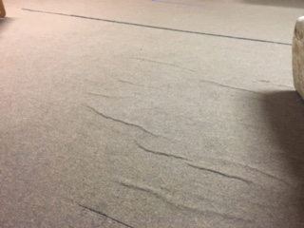
The total cost to replace the carpet with high-quality vinyl plank flooring is $14,000. It will cover all the rehearsal spaces in the basement.
You haven’t forgotten about “the gap,” have you?!
The “ripple effect” – not so great
on rehearsal carpet.

Think of it now. No tripping. No stains. No rip, tears or bubbles to see.
Imagine instead easily cleaned plank flooring that will last for years and years. Imagine the give that the floor will have. Imagine how grateful your legs will feel as you stand or dance on it for hours at a time.

There are three other floors that need to be replaced or that require maintenance out at the Pentacle (the stage floor, the bathroom floors, and the outside deck). The total for all the four flooring projects – including the rehearsal space – is $63,000. Here’s the good news. We have an individual who has agreed to provide $16,000 for a new stage floor (wow!). We’re seeking grants and other funds to cover the other projects.

Now here’s my idea: How about all those if us who have been part of a Pentacle production—including you—from the past three years pull together to replace the flooring in the rehearsal space?

The Pentacle has been and continues to be such a big part of our lives. This is our community theater. It runs because you contribute in some way—by acting, dancing, singing, volunteering…and by pitching in with critical financial donations for expenses just like this one.
Just think…the rehearsal space could look like this!
I’m coming to you to help us reach make this happen. The sooner we raise the money, the sooner we’ll get fabulous flooring in our rehearsal space.

Thank you, in advance, for helping to make our community rehearsal space better for you, for me, and for our community of fellow actors.

Yours,

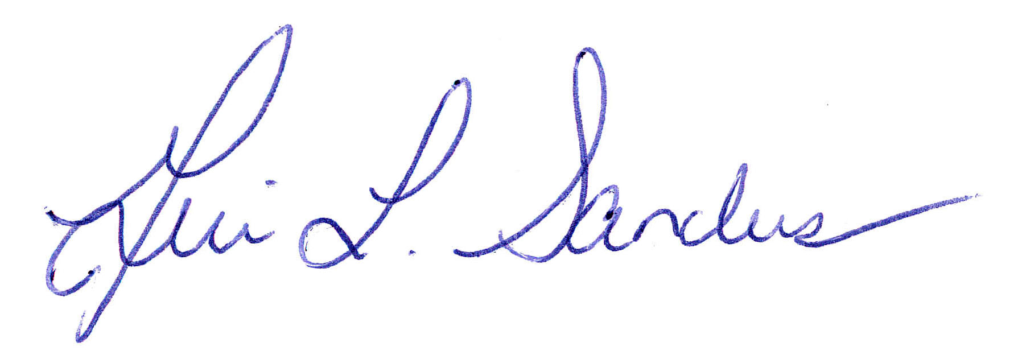

Geri Sanders
Proud Pentacle Actor

P.S You can give quickly and securely at pentacletheatre.org

P.P.S. Every donation is important! But if you give $100 or more, we’ll even post your name in the rehearsal space as a way to thank you!

