Candidate Name: David Ballantyne
As a board member I would be advocating for the theater in all moments of my life. I would advocate all the fantastic army of volunteers that make our life blood both onstage and off.
What volunteer work have you done for Pentacle Theatre?
- Actor – The Zoo Story (Received Outstanding Lead Male Performance in the Oregon AACT One Act Fest 2017 and Received Outstanding Lead Male Performance in the Region IX AACT One Act Fest 2017 competition for portrayal of Jerry in The Zoo Story), One Flew Over the Cuckoo’s Nest, All My Sons, The Importance of Being Earnest, The Desperate Hours, The Lion in Winter, The Underpants
- Director – Of Mice and Men
- Backstage doing Set work/Lights on many productions from 2011 to present
- Fundraiser Committee Member and Chair for two years 2012 to present
- Play Reading Committee 2013
- Personnel Committee 2017 to present
- Marketing Committee 2015 to present
- Social Media Manager 2012 to present
- Volunteer of the Year for Pentacle Theatre 2015
- Governing Board 2013-2016
What is your day job? What is your level of responsibility at this job?
- For the last 3 years I worked as a manager for the customer service center for the Oregon Health Plan. I started as a general supervisor before I became a program level manager.
- I served as the Interim Director of the Customer Service Center in 2017 before being asked to start new department in OHA.
- Some of my main duties and responsibilities were:
- Manage and oversee day-to-day operations of the Member Services processing center and its staff of 450, including several specialized teams and 23 managers.
- Use data and metrics to guide staff on workload decisions and continuous process improvements
- Develop long and short-range goals for multiple program areas and projects, including developing budgets, timelines, and metrics
- Develop and implement performance management plans for management staff and operational staff, driving accountability for both staff and management
- Create and foster a collaborative environment, partnering with many groups to influence our culture
- Develop talking points and reports for executive leadership regarding program changes, communication planning, and legislative requests
- Evaluate multiple program areas, instituting continuous improvement standards, LEAN methodology and the Plan Do Check Act model
- Develop and implement program-wide culture change, fostering new levels of morale and diversity through leadership, equity, and partnership
- Develop and implement internal communications to operational staff and management team
- Attend and represent the Oregon Health Authority at public meetings, presenting updates around complex information in sometimes hostile environments
- Managed and oversaw two satellite processing offices, managing multiple Oregon Health Plan programs in each; coordinated a successful consolidation of locations and
Please describe the skills and core competencies that you will bring to the board.
I am an excellent people person with strong interpersonal skills. I have experience in conflict resolution. I am very knowledgeable on budget driven decision making, collaborative team environments and achieving short and long-term goals.
Tell the members why you want to be a member of the Pentacle Board.
Pentacle Theatre has given so much to me and I am honored to be considered to serve again on the Governing Board. It is successful because of thousands and thousands of volunteer hours. I want to share some of the skill sets I have help keep Pentacle Theatre strong, so it may last another 65 years. I want to help keep building its financial stability, artistic quality and keep shining a light on one of our greatest cultural icons in the Mid- Willamette valley.
Please describe your goals for your three-year term, if elected:
- Keep building financial stability of Pentacle Theatre.
- Continue to increase marketing and branding efforts, making Pentacle even more of a known source of quality entertainment and cultural significance in the Mid-Willamette valley.
- Help build and foster the volunteer teams that make Pentacle Theatre a great place to be a part of!
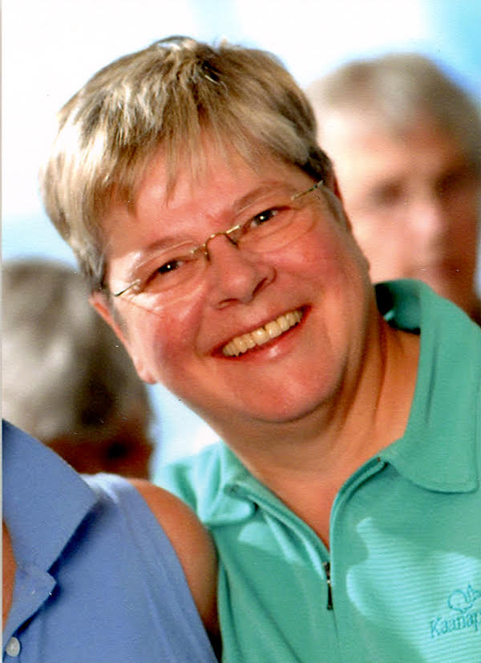
Candidate Name: Chris Fletcher
I love Pentacle Theatre. I want to continue to support and promote our theater as a member of the Governing Board. I want the theater I love to thrive and grow for generations to come. I will be an excellent ambassador. In fact, I consider myself to have been an ambassador for Pentacle Theatre for almost 50 years as an active member, donor, volunteer and staff person.
What volunteer work have you done for Pentacle Theatre?
I served two terms on the Governing Board in the 1980’s and was the theater’s salaried General Manager from 1985 to 1996. I became a Lifetime Member in 1994. I have been involved in over 60 productions in a variety of capacities including acting, directing and myriad backstage and booth positions. I have also served in some capacity on many committees, including the critical Play Reading Committee. As General Manager, I oversaw the first renovation of the theatre and wrote grant proposals that raised about $98,000 for that project. I also was instrumental in the creation of a $100,000 Endowment Fund through the Oregon Community Foundation.
I have a BA in Theatre from Portland State University.
What is your day job? What is your level of responsibility at this job?
I am a Travel Consultant and the owner of Top Dog Travel, which I started in 2007. Prior to that, I was co-owner of Raines Globe Travel in downtown Salem for 6 years.
Please describe the skills and core competencies that you will bring to the board.
I believe my long history with Pentacle Theatre, and especially the knowledge and skills I learned as General Manager, make me an ideal choice to serve the membership as a board representative. Among other things, I understand fundraising, grant writing, theater budgeting, and personnel. I have helped design many successful Pentacle seasons.
Tell the members why you want to be a member of the Pentacle Board.
I believe the Board’s chief responsibility is to ensure the financial health and stability of our organization. This is achieved, in my view, through a combination of creating quality, successful seasons, thanking and supporting our donors, finding sponsorships, careful budgeting, paying attention to maintaining our current season ticket holders and continually building our audience. My varied experience makes me uniquely qualified to assist with each of those endeavors.
Please describe your goals for your three-year term, if elected:
As for my goals for my three-year term, if elected, I would like to help the theatre continue to recruit and retain volunteers, not only onstage but backstage and on committees. I am keenly interested in audience development. The aging and lack of diversity of theater-goers is an ongoing problem with many theaters today and Pentacle is no exception. I would like to help the board work on solutions to build up and diversify the audience base. I am encouraged by the sponsorships the theatre is developing and my talents can be of use in that area as well.
Thank you for the nomination and this opportunity to serve Pentacle Theatre.
Candidate Name: Todd Logan
Hi Pentacle members,
My name is Todd Logan and I’m one of your candidates for the Pentacle Board. I’m a candidate because I’ve had a lot of fun playing at the theater over roughly the last decade, and I’d like to do my part to ensure that the theater remains a financially sound and artistically invigorating institution.
What volunteer work have you done for Pentacle Theatre?
Except for a few supportive duties when my kids have been in Pentacle shows, my own volunteer work with the theater has all been acting. I’ve appeared in seven productions since October 2008. I feel very fortunate to have been allowed to work with great people each time I’ve been involved in a show.
Please describe the skills and core competencies that you will bring to the board.
I think I’d be a useful Board member in part because of my educational background. My undergraduate degree is in Theater Arts, with an emphasis in acting, from the University of California, Santa Cruz. I also have a JD from Lewis and Clark Law School, and worked as an attorney in private practice for several years. If I’m elected to the Board, my approach to decision making will be informed both by my understanding of how a theater operates, and of what action a nonprofit board member can lawfully and appropriately take. As an attorney I obtained 501(c)(3) status with the IRS for one Oregon corporation, and have served on the board of two nonprofits, so I have some familiarity with the regulations and activities of nonprofit boards.
What is your day job? What is your level of responsibility at this job?
I work during the days for the state of Oregon as an administrative law judge. I mostly hear and decide cases arising under Oregon’s Implied Consent law, but I also conduct hearings on a variety of other types of suspension and revocation actions initiated by the Department of Transportation. I also periodically do hearings for unemployment insurance benefits. My work gives me an understanding that the best outcomes are typically decisions grounded in a solid understanding of the relevant facts, and that is an approach that I would adopt if working for the Pentacle Board. If elected, I would prioritize working collaboratively with the other Board members and seeking to promote a cohesive yet dynamic environment.
Describe how you will act as ambassador for the theater.
Actors function as an ambassador for the theater every time they step on stage, conduct an interview, appear in the lobby after a show, or answer questions while hanging posters. I think I have the background to function as a successful ambassador on behalf of the theater to the Salem community, to potential show sponsors, in grant applications, and to other entities beyond the audience for a particular show.
Please describe your goals for your three-year term, if elected:
I have no three-year plan, and no particular goals for the Board if I am given the opportunity to serve. I expect that my first year on the Board would be dedicated to working on Board committees, serving as Board liaison to productions, and learning the history, needs and priorities of the theater and the other Board members. After that, I expect to address whatever issues are pressing at the time. Members seeking to elect someone with a particular vision for the theater, or a desire to forge a direction for changes, should definitely vote for one of the other candidates. I don’t know enough about the Board’s operations to have such a vision, and whatever ideas I may have developed through my own connections with the theater are secondary to the belief that the primary responsibility of a Board member is ensuring that the Pentacle Theatre remains a vibrant cultural institution for the Salem community.
I hope the foregoing adequately addresses the questions asked in the “Candidate Statement,” but I’m happy to answer any questions or attempt to resolve any befuddlement I’ve inadvertently created. Thanks for considering all the candidates and choosing the ones you feel will do the best job!
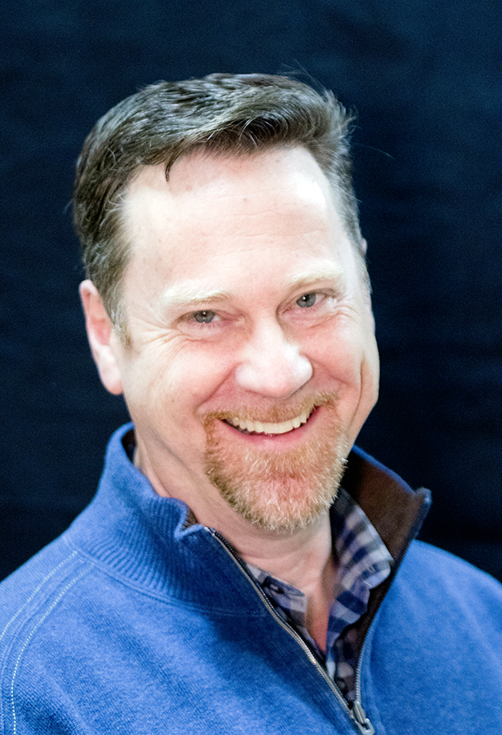
Candidate Name: Jon Stuber
Describe how you will act as ambassador for the theater.
- Actively promoting all aspects of the theatre
- Encouraging an ever-growing volunteer base
- Continued care, maintenance and appreciation of volunteers, staff and donors
- Continue involvement with my own volunteer opportunities as a working musician and learning new aspects of the theater experience
What volunteer work have you done for Pentacle Theatre?
- Musician for annual fundraisers (A Star is Born and Seussical)
- Audition pianist (Les Mis, A Christmas Carol, 9 to 5, etc.)
- Music Director for A Star is Born, Urinetown, and Jesus Christ Superstar
- Future stage manager (Calendar Girls and Savannah Sipping Society)
What is your day job? What is your level of responsibility at this job?
Account Manager at Aldrich Benefits – specialize in managing employee benefit plans with small and medium-sized groups. Assist with implementation, renewals and plan selection in healthcare. Assist clients in analysis and securing competitive group health plans that meet the needs of the company and their employees.
Please describe the skills and core competencies that you will bring to the board.
For 10 years, I served as coordinator and administrator of “Celebration Works – Concert and Art Gallery Series” at First Presbyterian Church, Portland. I managed all aspects of the series from contracting artists, administering contracts, developing budgets and coordination of volunteers. Responsibilities also included donor acquisition from inception to acknowledgment as well as appreciation events for volunteers, season sponsors and donors.
Served on the Board of Directors for Southwest Music School, 2004-2007. Worked with teachers, students, parents and community members in the implementation and maintenance of an after-school “music for all” type program.
Tell the members why you want to be a member of the Pentacle Board.
My progression from a passive audience member to involvement as a back-stage musician and finally a proud donor has been a journey of discovery. To find something about which you are passionate is truly one of the greatest gifts in life. I relish the opportunity to create a unique theater experience with friends both new and old. I have found that Pentacle Theatre naturally fosters a sense of family and encourages me to give back. This theater has given so much to me, I would be honored to return the favor.
Please describe your goals for your three-year term, if elected:
- Bring a fresh perspective and viewpoint, drawing from my experience in the Portland arts scene.
- Explore performance and business based strategies for growth and involvement
- Increase revenue
- Strengthen volunteer base
- Increase long-range revenue options through legacy and endowment opportunities
Develop donor programs for one-time events
- Sponsor a musician for a musical
- Sponsor a costume for a play
- Sponsor a set/prop

